Excel Assignment - 6

1. What are the various elements of the Excel interface? Describe how

they're used.

ANS. Excel Interface Components

Interface Components

The interface components of Excel include the Quick Access Toolbar, Ribbon, Name Box, Formula Quick Menu, Formula Bar, Status Bar, Worksheet View Options, Zoom Slider Control, and the Zoom Percentage Indicator.

Quick Access Toolbar

The Quick Access Toolbar is found on the top-left of the Excel window which contains the commonly-used commands in Excel. This toolbar can be customized and lets you choose which commands you want to access easily. By default, this contains the save, undo, and redo commands.

Ribbon

The Ribbon interface contains the commands that are available for use in Excel. This has multiple tabs including the File, Home, Insert, Page Layout, Formulas, Data, Review, View, Add-ins, and Help tabs. There are tabs that will appear when necessary; for example, the Format tab appears when you click an inserted shape.

Name Box

The Name Box is an input box which normally displays the name or location of the active cell on the worksheet. This is also used to directly create a named range. When you open a blank workbook, the selected cell is A1, by default.

Formula Quick Menu

The Formula Quick Menu beside the Name box is a shortcut when you want to insert a function. If you click the **fx**option, the Insert Function will pop-up to let you choose which Excel function would you like to use.

Formula Bar

The Formula Bar is found just beside the Formula Quick Menu. This allows you to enter or edit data, formula or a function that will appear in the selected cell whose name or location appears in the Name Box.

Status Bar

The Status Bar in the bottom-left corner of the Excel window displays various information about the current mode of the workbook.

Worksheet View Options

The Worksheet View Options lets you choose which of the 3 worksheet views you want (Normal, Page Layout, or Page Break Preview). By default, the worksheet view is set to Normal.

Zoom Slider Control

The Zoom Slider Control helps you zoom in and zoom out the worksheet.

Zoom Percentage Indicator

The Zoom Percentage Indicator displays the zoom percentage just beside the Zoom Slider Control. By default, it is set to 100%.

2. Write down the various applications of Excel in the industry.

ANS. A)Information Management.

B)Time Management.

C)Goal Planning & Tracking Progress.

D)Budget Management & Finance Tracking.

E)Data Analysis.

F)Data Visualization.

G)Expense Management.

H)Quick Calculations.

3. On the ribbon, make a new tab. Add some different groups, insert

commands in the groups and name them according to their commands

added. Copy and paste the screenshot of the steps you followed.

ANS. Go to File > Options > Customize Ribbon.

Right-click on the ribbon and select Customize the Ribbon… from the context menu:

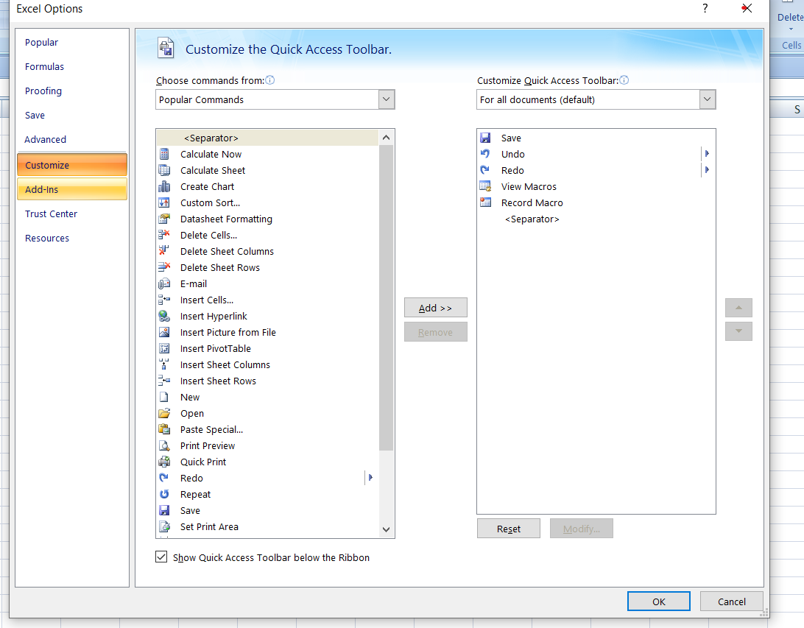

--Select the newly created tab, named *New Tab (Custom)*, and click the **Rename…** button to give your tab an appropriate name. In the same manner, change the default name given by Excel to a custom group. For the detailed guidelines, please see [how to rename ribbon items](https://www.ablebits.com/office-addins-blog/customize-ribbon-excel/#rename-tabs-groups-command).

--When done, click *OK* to save the changes.

4. Make a list of different shortcut keys that are only connected to

formatting with their functions.

ANS.

|  |  |
| --- | --- |
| Open the **Format Cells** dialog box. | Ctrl+1 |
| Format fonts in the **Format Cells** dialog box. | Ctrl+Shift+F or Ctrl+Shift+P |
| Edit the active cell and put the insertion point at the end of its contents. Or, if editing is turned off for the cell, move the insertion point into the formula bar. If editing a formula, toggle Point mode off or on so you can use the arrow keys to create a reference. | F2 |
| Insert a note.  Open and edit a cell note. | Shift+F2  Shift+F2 |
| Insert a threaded comment.  Open and reply to a threaded comment. | Ctrl+Shift+F2  Ctrl+Shift+F2 |
| Open the **Insert**dialog box to insert blank cells. | Ctrl+Shift+Plus sign (+) |
| Open the **Delete**dialog box to delete selected cells. | Ctrl+Minus sign (-) |
| Enter the current time. | Ctrl+Shift+Colon (:) |
| Enter the current date. | Ctrl+Semicolon (;) |
| Switch between displaying cell values or formulas in the worksheet. | Ctrl+Grave accent (`) |
| Copy a formula from the cell above the active cell into the cell or the formula bar. | Ctrl+Apostrophe (') |
| Move the selected cells. | Ctrl+X |
| Copy the selected cells. | Ctrl+C |
| Paste content at the insertion point, replacing any selection. | Ctrl+V |
| Open the **Paste Special** dialog box. | Ctrl+Alt+V |
| Italicize text or remove italic formatting. | Ctrl+I or Ctrl+3 |
| Bold text or remove bold formatting. | Ctrl+B or Ctrl+2 |
| Underline text or remove underline. | Ctrl+U or Ctrl+4 |
| Apply or remove strikethrough formatting. | Ctrl+5 |
| Switch between hiding objects, displaying objects, and displaying placeholders for objects. | Ctrl+6 |
| Apply an outline border to the selected cells. | Ctrl+Shift+Ampersand sign (&) |
| Remove the outline border from the selected cells. | Ctrl+Shift+Underscore (_) |
| Display or hide the outline symbols. | Ctrl+8 |
| Use the **Fill Down** command to copy the contents and format of the topmost cell of a selected range into the cells below. | Ctrl+D |
| Apply the **General**number format. | Ctrl+Shift+Tilde sign (~) |
| Apply the **Currency**format with two decimal places (negative numbers in parentheses). | Ctrl+Shift+Dollar sign ($) |
| Apply the **Percentage**format with no decimal places. | Ctrl+Shift+Percent sign (%) |
| Apply the **Scientific**number format with two decimal places. | Ctrl+Shift+Caret sign (^) |
| Apply the **Date**format with the day, month, and year. | Ctrl+Shift+Number sign (#) |
| Apply the **Time** format with the hour and minute, and AM or PM. | Ctrl+Shift+At sign (@) |
| Apply the **Number**format with two decimal places, thousands separator, and minus sign (-) for negative values. | Ctrl+Shift+Exclamation point (!) |
| Open the **Insert hyperlink** dialog box. | Ctrl+K |
| Check spelling in the active worksheet or selected range. | F7 |
| Display the **Quick Analysis** options for selected cells that contain data. | Ctrl+Q |
| Display the **Create Table** dialog box. | Ctrl+L or Ctrl+T |
| Open the **Workbook Statistics**dialog box. | Ctrl+Shift+G |

5. What distinguishes Excel from other analytical tools?

ANS. Excel is a powerful and versatile tool that is well-suited for a wide range of data analysis and management tasks, and it has a large user base and a wide range of functionality.

6. Create a table and add a custom header and footer to your table.

ANS. Click the worksheet where you want to add or change headers or footers.

Go to **Insert** > **Header & Footer**.

Excel displays the worksheet in **Page Layout** view.

To add or edit a header or footer, select the left, center, or right header or footer text box at the top or the bottom of the worksheet page (under **Header**, or above **Footer**).

Type the new header or footer text.

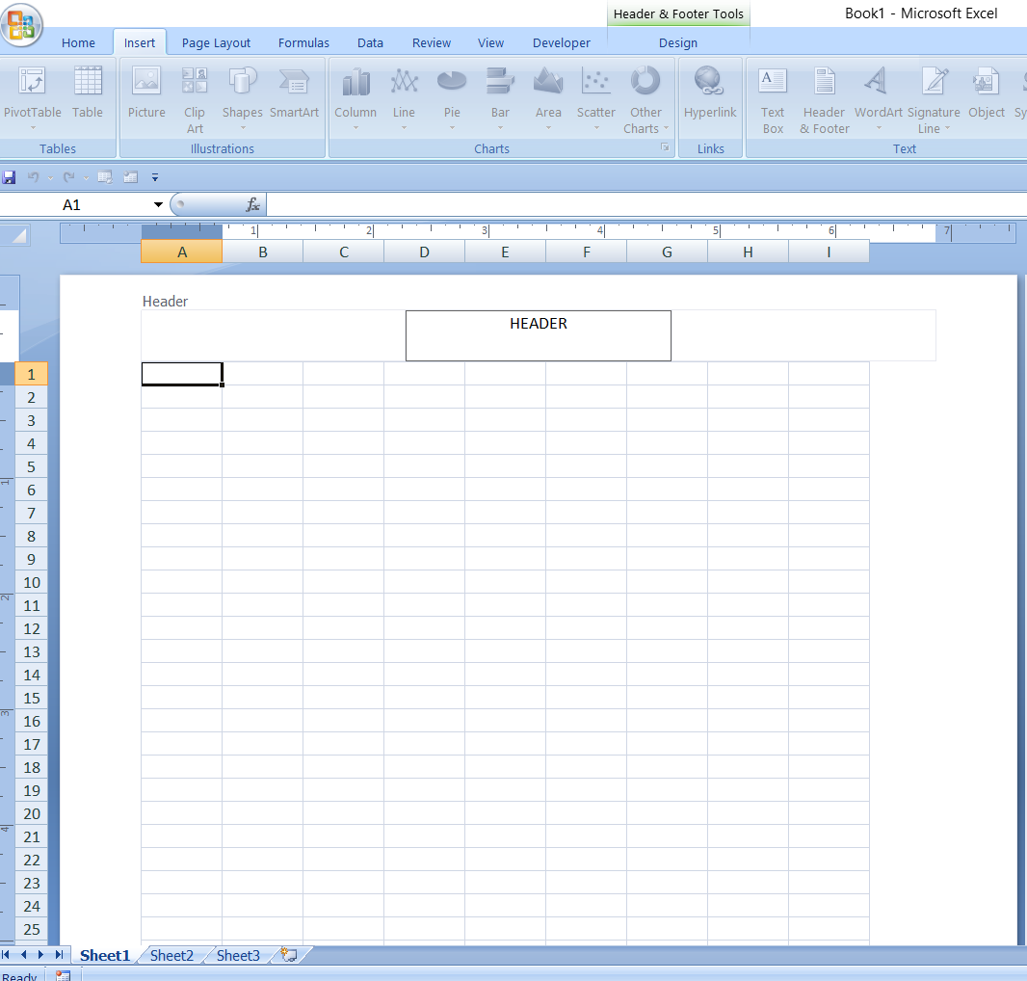

That’s how we add a header in excel worksheet